SAMIR KUMAR PANDA 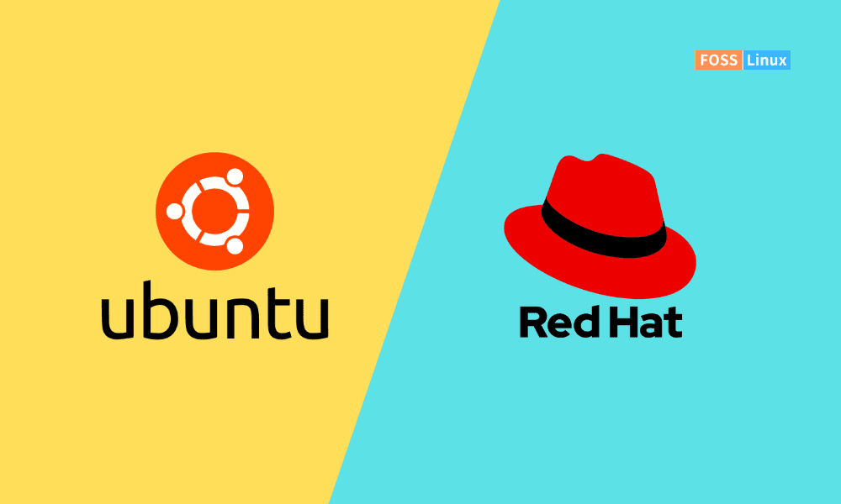
DevOps Engineer
Gurugram, India
📧 Email: samirpanda299@gmail.com | 📱 Phone: +91 7853852789
LinkedIn: www.linkedin.com/in/sameer-panda-35a383269

PROFESSIONAL SUMMARY

Experienced DevOps Engineer with over 4+ years of Experience with expertise in deploying and managing Kubernetes clusters, building infrastructure on AWS using Terraform, and utilizing Docker for containerization. Strong skills in shell scripting and managing end-to-end client journeys, from onboarding to post-go-live support.

PROFESSIONAL EXPERIENCE

Minoan, Gurugram

Devops engineer

july 2023 – present

Optimized platform stability and scalability across multiple environments by deploying and managing Kubernetes clusters on AWS and client servers, ensuring seamless application delivery for various clients..

- Architected and deployed a microservices-based architecture using Kubernetes to enhance application modularity and scalability.
- Designed custom Helm charts for consistent and repeatable application deployments across multiple environments (Dev, QA, Staging, Production).
- Built robust CI/CD pipelines using tools like Jenkins, GitLab CI, and ArgoCD, enabling zero-downtime deployments and faster feature rollouts.
- Integrated Ingress controllers (NGINX) for traffic management and secure external access using SSL certificates.
- Configured Kubernetes Secrets and ConfigMaps for secure and flexible application configurations.
- Enabled dynamic scaling of workloads through Horizontal Pod Autoscaler (HPA) and Vertical Pod Autoscaler (VPA) based on real-time metrics from Prometheus.
- Automated node scaling using Cluster Autoscaler in GCP’s GKE, optimizing resource utilization and minimizing costs.
- Implemented network policies to enforce fine-grained communication between microservices, ensuring security and compliance.
- Conducted disaster recovery planning by implementing Kubernetes StatefulSets and persistent volumes for data retention.
- Set up logging and monitoring solutions using Prometheus, Grafana, and ELK Stack (Elasticsearch, Logstash, Kibana) for observability and proactive incident management.
- Experience in building Continuous Integration (CI) & Continuous Deployment/Delivery (CD) pipeline as an iterative process using Jenkins.
- Configured Jenkins Master-Slave Architecture using Jenkins Nodes to build jobs in the view of distributing the load of Jenkins Master and achieved parallel builds.
- Knowledge on matrix based security in Jenkins to restrict the users of Jenkins at different levels.
- Successfully integrated Nexus Repository with Jenkins for artifacts storage and downloading artifacts for deploying it to applications and for testing.
- Successfully integrated Sonar Qube with Jenkins for Continuous Inspection of Code Quality.
- Expertise in Configuration Management Tool like Ansible and in writing Playbooks and creating Roles for Scalability and Reusability.
- Expertise in installing of Apache, http, Apache Tomcat and Nginx using Ansible Playbooks and configure these packages.
- Expertise in creating and maintaining the infrastructure on AWS.
- Expertise in AWS to manage and configure EC2 services such as EC2-instances, AMI, IAM, ELB, EBS, RDS, and S3.

Impact:
- Achieved a 50% reduction in deployment times through automation and standardized processes.
- Enhanced application uptime and reliability by leveraging Kubernetes’ self-healing and scaling capabilities.
- Reduced infrastructure costs by 30% through efficient resource scaling and monitoring.
- Improved security posture by implementing encrypted secrets and strict network policies.
Technologies:
Kubernetes, Helm, Docker, Jenkins, GitLab CI, ArgoCD, Prometheus, Grafana, ELK Stack, NGINX, Cluster Autoscaler

Sinch, Noida
Devops engineer
Aug 2022 - May 2023

Streamlined and optimized multi-cloud infrastructure, deploying and managing AWS EKS microservices applications with Istio, Helm, and Rancher, ensuring high availability, security, and seamless customer delivery.

- Actively interacted with an Enterprise company customer end-to-end Architecture Prepared and project delivered successfully.
- Highly recommended multi- cloud infrastructure management Rancher with Istio, Helm to build AWS EKS micro services applications.
- Configured Name Spaces, Pods configured POD to POD Security with Istio Services.
- Built micro-services application by using AWS- EKS and NLB, ALB, Route53, Firewalls has configured for externally user access as per customer required.
- Monitoring level configured Prometheus, Grafana, Kiali, Jaeger, calico
- Working as my Organization level multi- cloud portal implementing as part AWS DevOps API calls integrating.
- Actively worked setup completed with native tools of AWS-DevOps
- Used tools (Code- Commit, Code-Build, Code-Pipeline, and Code-start for Jira)
- Aws-DevOps CI/CD setup handed over to Audit team. And containers as micro services application.
- Organized Configuration Management involving Identification, Versioning and complete build & release management of all the configurable items.
- Managed the source code control of multiple development environments using SVN, and GITLAB.
- Responsible for build and deployment at different levels of development, test and production environments.
- Automating build and deployments using continuous integration tools like Jenkins.
- Automating build using build scripts like ANT, Maven.
- Responsible to create containerized environment and performing deployments using custom Docker images.
- Generating Docker file to create a customized Docker image and maintaining at art factory.
- Involved in setting up and maintaining auto-scaling AWS stacks (preferred using cloud formation and scripting using bash & python).
- Automated daily manual tasks/tests by running corn jobs.
- Launching and configuration of Azure VM instances using Azure Stored Image.
- Implemented setup for Master slave architecture to improve the performance of Jenkins.
- Demonstrated expertise in developing smart contracts and decentralized applications (dApps) on the Ethereum blockchain, utilizing Solidity for smart contract development and Web3.js for front-end integration.
- Managed Raft clusters, including the assignment and management of Raft IDs, to ensure high availability and fault tolerance.
- using Docker and Docker Compose for containerization of Quorum nodes and Tessera services. This included setting up and managing multi-container Docker environments to simulate a Quorum network.
- Deployed smart contracts and Apps on the Quorum blockchain, showcasing the ability to develop, test, and deploy blockchain solutions that meet business requirements.
- Utilized tools such as Prometheus and Grafana for monitoring and analyzing blockchain network performance, identifying bottlenecks, and optimizing network efficiency.

Cubespace Technologies, Bengaluru Sept 2019 – Aug 2022
DevOps engineer

Enhanced cloud infrastructure performance and scalability by orchestrating Docker containers, managing AWS resources (EBS, Route 53, S3, Glacier), and automating CI/CD pipelines using Git, Maven, and Jenkins for seamless application deployment and high availability.
- Experience in orchestrating Docker containers for streamlined application deployment.
- Increased EBS-backed volume storage capacity when the root volume was full using AWS EBS volume resizing.
- Configured AWS Route 53 for traffic routing between different regions.
- Created S3 backups with versioning enabled and archived objects to Amazon Glacier for long-term storage.
- Designed and implemented Elastic Load Balancers (ELB) with failover and latency-based routing using Route 53 to ensure high availability and fault tolerance.
- Built source code using Git, Maven, and Jenkins for CI/CD pipeline automation.
- Developed and executed build and deployment scripts adhering to SCM standards for QA, UAT, and production environments.
- Performed weekly scheduled builds and deployments to all environments after process setup completion.
- Verified system and application logs daily to identify and prevent potential issues.
- Created and managed clusters and servers in cloud environments for scalable application hosting.
- Deployed applications on Apache Tomcat servers using Ansible for automated provisioning.
- Analyzed logs to identify and resolve errors efficiently, focusing on specific issues during a given timeframe.
- Created AMIs from instances, generated snapshots for volumes, configured security groups, and managed access restrictions.
- Resolved deployment issues in Tomcat by analyzing logs and addressing errors.
- Configured admin, system, application, and web logs in Sumo Logic for centralized log monitoring.
Technologies :
Docker, AWS (EBS, S3, Route 53, ELB, Glacier, AMIs), Git, Maven, Jenkins, Ansible, Apache Tomcat, Linux, Bash, Shell Scripting.

SKILLS

Kubernetes - Docker - Jenkins - Bash Scripting - Linux - Docker Swarm - Ansible - Terraform - RestAPI - OpenSearch - Vault - Prometheus - Grafana - Openshift - Helm Charts - NodeJS - Javascript - Redis - Elasticsearch - MongoDB - MySQL - Operating Systems - Github - Bitbucket - JIRA
AWS Services: EC2, EKS, IAM, S3, ALB, VPC, Networking, Lambda, RDS, DynamoDB, ElastiCache, EBS, Glacier, Route 53, API Gateway, CloudWatch, CloudTrail, Secrets Manager, KMS, CodeCommit, CodeBuild, CodePipeline, ECS, ECR, Fargate

EDUCATION BHARATH UNIVERSITY, CHENNAI Chennai, India
B.Tech ( Electrical and Electronics Engineering ) 2011 - 2015

HOBBIES

- Playing/Watching cricket.
- Enjoying long bike rides with friends or family.
- Likes to explore various cultures, including their food and activities.

LANGUAGE

- English : Proficient
- Hindi : Proficient
- Odia : Native

