Kuldeep Jadhav  Panchshella,S-No3,  Near Indian Education school,  Vadgaon sheri,  Pune - 411014.  Email: kuldeep.jadhav@live.com  Mobile: +91 9421010243. | 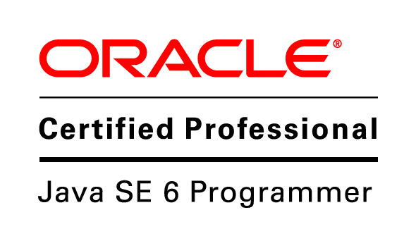

Technical Lead, Full Stack Developer(Manager).
Kuldeep currently works with Qualys Inc as lead(Manager) and comes with 11.5 years experience. He has an extensive experience in building distributed scalable enterprise applications, has good knowledge of Object oriented principles, Design Patterns, System design, UI /backend Development and testing.
Qualys Experience

Lead/Engg Manager for ApiSecurity Module(Beta) (almost 2 years: June 2019)

The product is providing application security to services right from development, CI/CD phase to deployment in production. This product is in collaboration with a startup named 42crunch. Leading a team of 4 people. Responsible for all the design decisions. Also involved in code reviews and conducting interviews.
Development phase: We have developed intellij plugin https://plugins.jetbrains.com/plugin/15361-swagger-openapi-security-assessment
CI/CD: https://plugins.jenkins.io/qualys-api-security/
Module overview: https://www.qualys.com/docs/qualys-api-security-getting-started-guide.pdf

Technologies:
Backend: Java, Spring Boot, Apache Kafka, Oracle, elasticsearch, redis, python(basic).
Frontend:ReactJs/Redux
Deployment: Kubernetes, Docker

Lead for Reporting Service (July-2021 onwards )

This service is a shared service.It is used for report generation by other modules.
Technologies
Backend: NodeJs, Oracle
Deployment: Kubernetes, Docker

Lead for VMDR(Middleware) (July-2019 till Feb-2020 )

This product is Qualys’s flagship product. The product was aimed at providing customer a single view to see the vulnerabilities, prioritize them, and take some action on them . We were responsible for the middleware part of the application.
Technologies
Backend: Java, Google Guice, Spring boot, Oracle, elasticsearch.
Frontend:ReactJS,Redux,Babel,Webpack
Deployment: Kubernetes, Docker

Senior Software Engineering/Lead for Security Assessment Questionnaire Module (July-2017 till July 2019)

This product is part of the compliance suite provided by Qualys. This is used for procedural compliance.
Started as Senior Software Engineer and moved to Lead position. Was responsible for all the design decisions for the project. Played an important role in migrating the project from extjs/dwr to React/Rest based application. Added a lot of key features to the module.
Technologies
Backend: Java, Google Guice, Oracle.

Frontend:ReactJS,Redux,Babel,Webpack

Other Experience

CDK Global (India) Private Limited, Pune (July 2013– July 2017)

Project: Content Management System
This was an internal tool responsible for managing content to be posted on the dealer website. Was responsible for adding new features to the module. Wrote functional tests for the module using ConceptJs
Technologies
Backend : NodeJs, ConceptJs
Frontend : Vanilla Javascript

Project: Social Manager and Reputation Management
CDK Digital Marketing’s Reputation Management seamlessly builds review generation into the car sales process, making it incredibly easy to capture dealer reviews and put them in the spotlight, empowering dealers to monitor and stay on top of their online reputation.

Kuldeep was actively involved in developing web-based as well as mobile-based solution for this product. He was actively involved breaking down the monolithic services to scalable Microservices architecture. He was responsible for analysis, design and development of the complete feature. He was involved in implementing CI/CD, clean code practices and helped in creating automated test suites.

Technologies
Backend : Java, Spring Boot, Oracle
Frontend : AngularJS, Hybrid Mobile App using (Ionic, PhoneGap)

Persistent Systems, Pune (July 2010- July 2013)

Project: Agilent SureDesign (Life Sciences Domain Project)
SureDesign is a web-based sequencing platform used by various scientists, Universities and Agilent Users etc. for sequencing and analysis of human genome.
Kuldeep was involved in developing completely new and intuitive web platform, that gives researchers flexibility to streamline entire project. Kuldeep was involved in implementing UI, generating various reports for researches, creating backend services and batch utility that would enable to sequence large volume of data. He was also involved in migrating existing users and their data from old product to the new product.

Technologies
Backend : Java, Spring Boot, Spring Batch , JSP 2.0
Frontend : Dojo 1.7
Skills
- Programming Languages: Java, PL/SQL, NodeJS, Javascript
- Databases: Oracle, Elasticsearch
- Tools/Frameworks: Spring Framework, Hibernate, Kafka, Junit, Mockito
- Practices: Microservices, CI/CD, Design Patterns
- Deployments: Kubernetes, Atlassian Bamboo, Jenkins
- Frontend Technologies: ReactJS/Redux, AngularJS
- Project Management Tools: Jira
- Domains: Security and Compliance, Automobile, Life Sciences.
- Methodologies: Agile (Scrum), Waterfall

Education
- Bachelor of Engineering in Information Technology: MAEER’s MIT, Pune University, Pune, India. (2006 - 2010)

Degree/Standard | Passing  Year | Board/University | Percentage
Bachelor of Engineering(B.E) in Information Technology. | 2010 | University of Pune. | 67.20 %
Higher Secondary Certificate (HSC) | 2006 | Maharashtra Board | 82.83 %
Secondary School Certificate (SSC) | 2004 | Maharashtra Board | 82.93 %

Achievements
- Awarded for an outstanding performance in CDK Global
- Appreciated with ‘Pat on Back’ award for Notable Performance in CDK Global
- Participated in national level software project exhibition and competition held at ‘Priyadarshini College of Engineering', Nagpur and secured First Prize.
- Participated in national level software project exhibition and competition held at ‘D Y Patil College of Engineering', Pune and secured First Prize.

