T M DEEPA RANI
CSPO & CSM

Product Line Manager: Connectivity-IoT Solutions
(Self-Driven and Strategic Thinker) tmdeepa@gmail.com Mobile: +91- 8123734498

Personal attributes as a meticulous, cautious risk taker hold me in good stead in building loyalty and peak performance.

Professional Summary

- Result Oriented and passionate Product Manager with 10 years of experience in building Connectivity IOT (Internet of Things) Products.
- Possess rich experience in leading Product team’s towards Dell Digital transformation
- Experience working in US, Canada and Ireland leading various Product portfolios from Inception to Deployment/Marketing.

Core Competencies

- T Shaped - Product Manager - IoT Technology Stack
- Team Leadership and Development
- Customer Centric - UX Design
- Business Acumen
- Technical Project Management
- Mentoring and Coaching

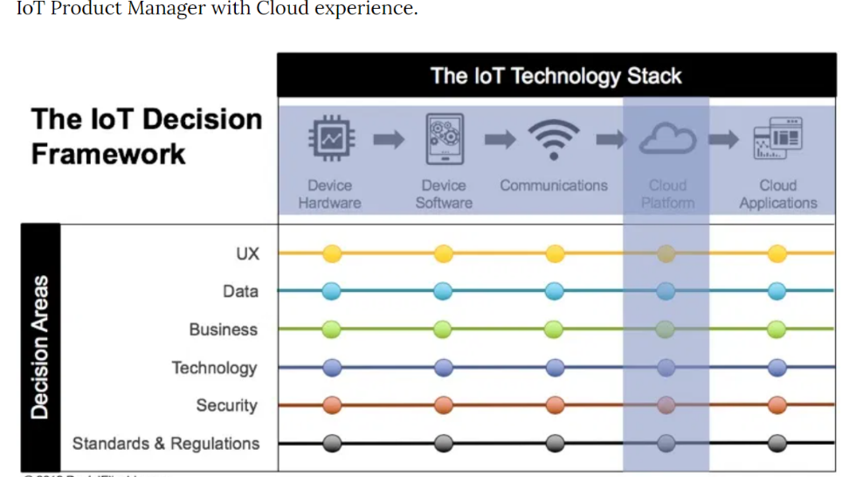

Skill Sets
- Certified through Scrum Alliance – CSPO (Certified Scrum product Owner) and CSM (Certified Scrum Master)
- Domain Areas: Comprehensive knowledge of Connectivity-IoT Applications, Multiple storage technologies, SAN-based arrays, and configuration tools. Payments (services), Payment Gateway, Financial services Fraud Model
- Project Management: Rally, Jira, Version One, TFS Team Foundation Server.
- Development Methodologies: Agile Software Development Methodology Well versed with Scrum and Kanban. Spotify Engineering Culture with Tribes, Squads, Chapters &Guilds

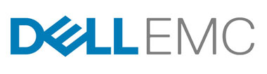
Senior Product Manager for Connectivity-IoT, Product Line in DELLEMC.
From April 2014- Till Date

- Leading the development of next generation IoT platform of Secure Remote Services a two-way remote connection between DellEMC Customer Service and Dell EMC Enterprise products that enables remote monitoring, diagnosis and File transfers.
- Driving the definition of Connectivity platform capabilities across combined companies post the merger of Dell and EMC in 2016
- Partnering with business to define the long-term strategy for IOT capabilities, OGSM (Objectives, Goals, Strategies and Measures) driven product line roadmaps for faster delivery.
- Experience in driving Product portfolio in DELLEMC Connectivity IOT Solutions, NPI/Enhancements from Inception to Release, Program Plan, Schedule, Risk Management, cross dependencies, track, report/escalate issues as needed to Stakeholders and Business executives.
- Leverage customer feedback, production data, & business need to drive an outcome-based product roadmap across the product line.
- Collaborate with Product Managers, Business partners and Engineering/ R&D leaders to align product strategies into comprehensive portfolios for DELLEMC Connectivity – IoT Solutions.

Work History

Product Analyst and Team Lead in Signiant, Ness Technologies. Bangalore from Nov 2011 till Feb 2014

Leads strategy & execution across product line by prioritizing run, growth, & transform level problems
- Prioritize the features/User stories for the Scrum teams analyzing the dependencies between the cross functional scrum teams.
- Define Engineering best Agile practices from process perspective to help the scrum teams to stay focused on the deliverables
- Responsible for sending Release Announcements and Release Notes, updating user guide and manuals.
- Highly capable of mentoring team members and empower them to realize their potential.


Quality Team Lead and Test Analyst in PayPal, Ness Technologies. Chennai from Oct 2006 till Nov 2011.
- Good experience in Preparing Test Strategy, Test Plan, Requirements Traceability Matrix, Test Cases, Test Report and Test Metrics, Defect Metrics, Status Reports
- Experience in GUI Testing, Web Testing, Functionality Testing and Integration Testing, Component level Testing, System Testing, Regression Testing, Business Process Testing.
- Experience in creating Product Portfolio Roadmap and Collaborative Requirements Analysis - defining the “MVP & MVF” (Minimum Viable Product and Minimum Viable Feature)
- Consistently deliver critical capabilities to the Enterprise Products, enabling use cases for Customer Support, Data Analytics, Product Engineering and revenue enablement.

Educational Qualifications:
B.Tech (Distinction) in Electrical and Electronics - Sri Venkateshwara University, Tirupati AP

